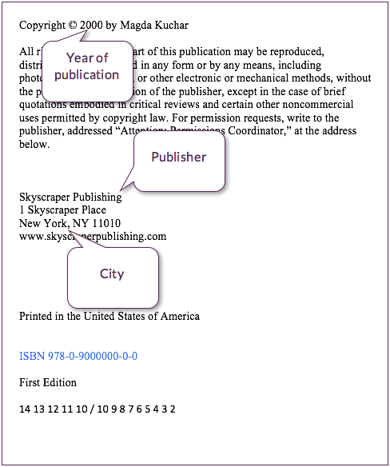../../Downloads/thumbnail_open.png

**Source is fictional**